Technical Recommendation
Model：BRTIRPZ1825A
Name：Four axis robot
Robot version:21 version
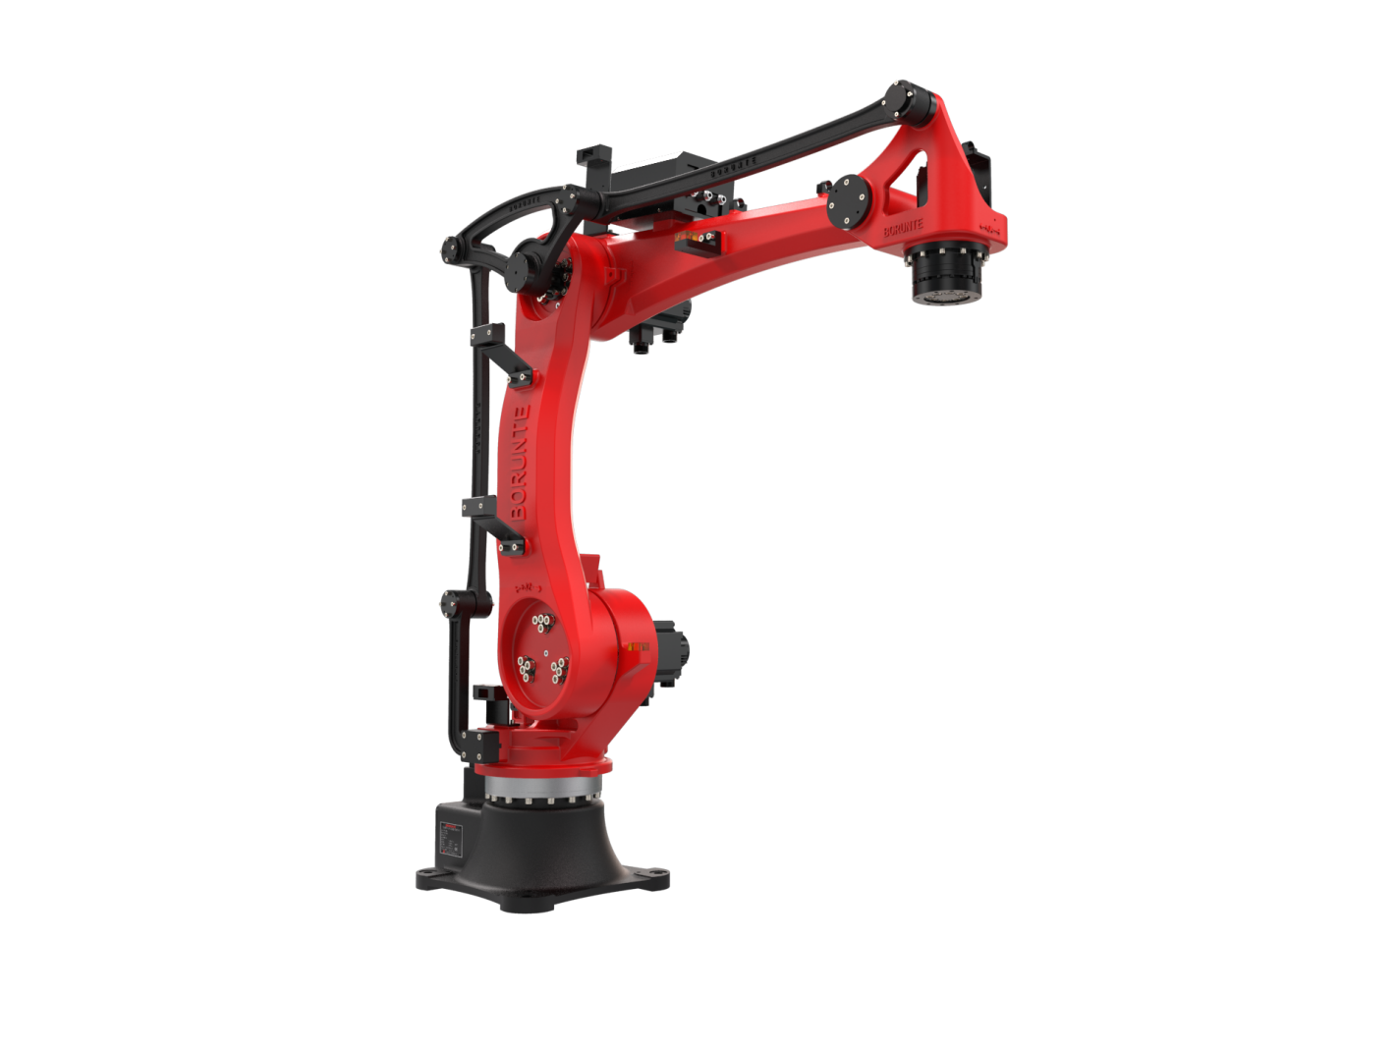

（Without further notice if specification and exterior have been changed because of improvement. Thanks for your understanding.）

1. BRTIRPZ1825A robot profile

1.1.Introduction of BRTIRPZ1825A

BRTIRPZ1825A is a four axis robot developed by BORUNTE for certain monotonous, frequent, and repetitive long-term operations, as well as hazardous and harsh environments. It has an arm span of 1800mm and a maximum load of 25kg. With multiple degrees of flexibility, it can be used in loading and unloading, handling, unstacking, and stacking.
High accuracy: Repeated positioning accuracy: ±0.08mm.

1.2. Application cases of BRTIRPZ1825A

(1). stamping (2). palletizing (3). loading and unloading, etc.

2. BRTIRPZ1825A robot specifications
Model | BRTIRPZ1825A
Axes | 4 axis
Loading ability | 25kg
Repeated positioning accuracy | ±0.08mm
Maximum arm span | 1800mm
Weight | 256kg
Max speed | J1 | 175°/s |  |  | J2 | 135°/s
Max speed | J3 | 123°/s |  |  | J4 | 300°/s
Motion range | J1 | ±155° |  |  | J2 | -78°/+30°
Motion range | J3 | -62°/+ 70° |  |  | J4 | ±360°
Motion range | R34 | 65°~170° |  |  | / | /
Allowable torque | J4 | 62.3N*m
Allowable moment of inertia | J4 | 0.145KG*m²
Mounting environment | Operating temperature： 0℃-40℃ Best temperature：15℃-25℃  Relative humidity：20-80%RH（No condensation） |  |  |  | Mpa | 0.5~0.7MPa
Mounting environment |  |  |  |  | Power supply | 220V±10％  50HZ/60Hz
Core components | Name | Operating system |  |  | Brand | BORUNTE
Core components | Name | Casting body |  |  | Brand | BORUNTE
Core components | Name | Servo motor |  |  | Brand | BORUNTE
Core components | Name | Reducer |  |  | Brand | BORUNTE
Core components | Name | Electrical component |  |  | Brand | BORUNTE
RV Oil content | J1 | 1700ML | J2 | 860ML | J3 |  | 660ML
RV Oil content | J4 | /
Vulnerable parts | None
Robot accompanying materials | USB

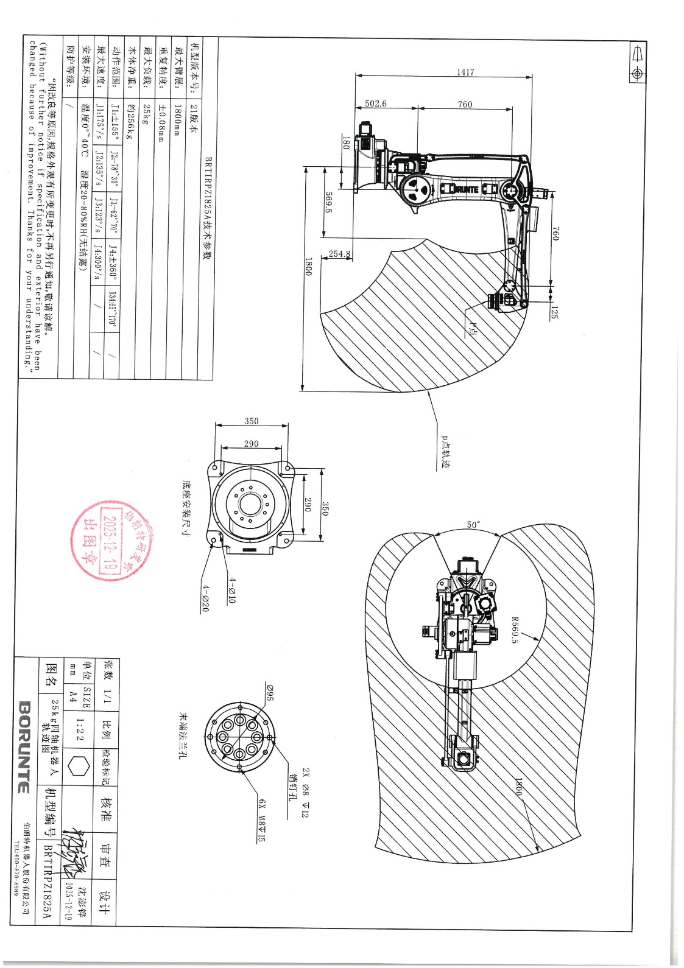
The rated power, specifications, external dimensions, etc. of this product are subject to modification without prior notice. Technical data and illustrations are for supply reference only and reserve the right to makechanges.

