Technical Recommendation
Model：BRTIRUS1820A
Name：Six axis robot
Robot version :21 version

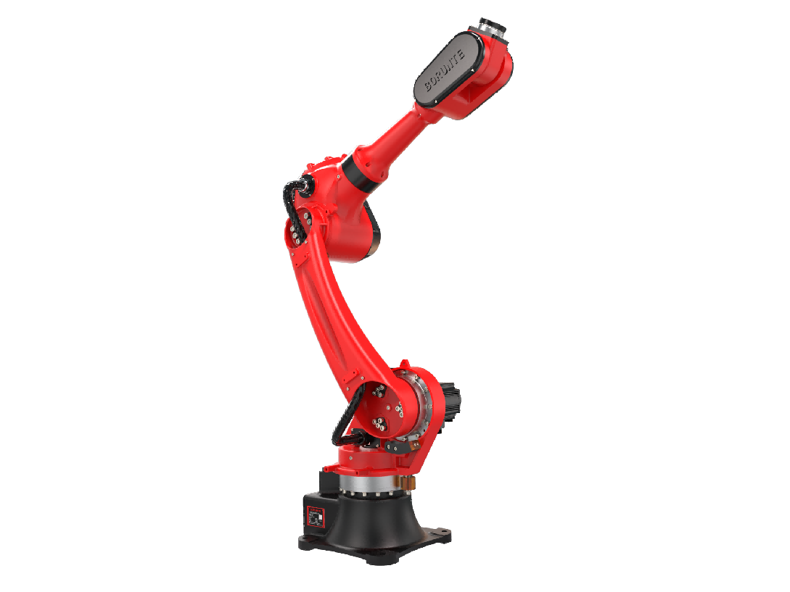

（Without further notice if specification and exterior have been changed because of improvement. Thanks for your understanding.）

- BRTIRUS1820A robot profile
  - Introduction of BRTIRUS1820A

BRTIRUS1820A is a six axis robot developed by BORUNTE for complex applications with multiple degrees of freedom. 20kg loading ability, 1895mm arm span. Adopting a lightweight arm design, the mechanical structure is compact and concise, and can perform flexible operations in a narrow workspace under high-speed motion, meeting the needs of flexible production. With six degrees of flexibility, it can freely handle scenarios such as loading and unloading, injection molding, die-casting, assembling, gluing, polishing, and testing. Suitable for injection molding machines: 500T-1300T.
High IP code：Wrist: IP54 Body: IP40
High accuracy：repeated positioning accuracy: ±0.05mm

1.2. Application cases of BRTIRUS1820A
(1). injection molding (2). stamping (3). transporting (4). loading and unloading, etc.
Model | BRTIRUS1820A
Axes | 6 axis
Loading ability | 20kg
IP code | Body: IP40 Wrist: IP54
Repeated positioning accuracy | ±0.05mm
Maximum arm span | 1895mm
Weight | 230kg
Max speed | J1 | 110°/s |  |  |  |  |  |  | J2 |  | 146°/s
Max speed | J3 | 134°/s |  |  |  |  |  |  | J4 |  | 273°/s
Max speed | J5 | 240°/s |  |  |  |  |  |  | J6 |  | 375°/s
Motion range | J1 | ±155° |  |  |  |  |  |  | J2 |  | -140°/+65°
Motion range | J3 | -75°/+110° |  |  |  |  |  |  | J4 |  | ±180°
Motion range | J5 | ±115° |  |  |  |  |  |  | J6 |  | ±360°
Mounting environment | Operating temperature： 0℃~40℃  Best temperature：15℃~25℃  Relative humidity：20~80% RH（No condensation） |  |  |  |  |  |  |  |  |  | Mpa |  |  |  | 0.5~0.7 MPa
Mounting environment |  |  |  |  |  |  |  |  |  |  | Power supply |  |  |  | 220V±10％ 50Hz/60Hz
Allowable torque | J4 | 52N*m |  |  |  | J5 |  | 56N*m |  |  |  | J6 |  | 51.2N*m
Allowable moment of inertia | J4 | 0.664048kg*m² |  |  |  | J5 |  | 1.12kg*m² |  |  |  | J6 |  | 0.3968kg*m²
Core components | Name | Operating system |  |  |  |  | Brand |  |  |  | BORUNTE
Core components | Name | Casting body |  |  |  |  |  |  |  |  | BORUNTE
Core components | Name | Servo motor |  |  |  |  |  |  |  |  | BORUNTE
Core components | Name | Reducer |  |  |  |  |  |  |  |  | BORUNTE
Core components | Name | Electrical component |  |  |  |  |  |  |  |  | BORUNTE
Oil content | J1 |  | 1400ML |  | J2 |  |  |  |  | 1000ML |  |  | J3 |  |  | 800ML
Oil content | J4 |  | 250ML |  | J5 |  |  |  |  | / |  |  | J6 |  |  | /
Vulnerable parts | Timing belt |  |  | MBT233080505 timing belt 5M-8 bandwidth -85 tooth
Robot accompanying materials | USB
- BRTIRUS1820A robot specifications

The rated power, specifications, external dimensions, etc. of this product are subject to modification without prior notice.
Technical data and illustrations are for supply reference only and reserve the right to make changes.

