Technical Recommendation
Model：BRTIRUS2550A
Name：Six axis robot
Robot version :21 version
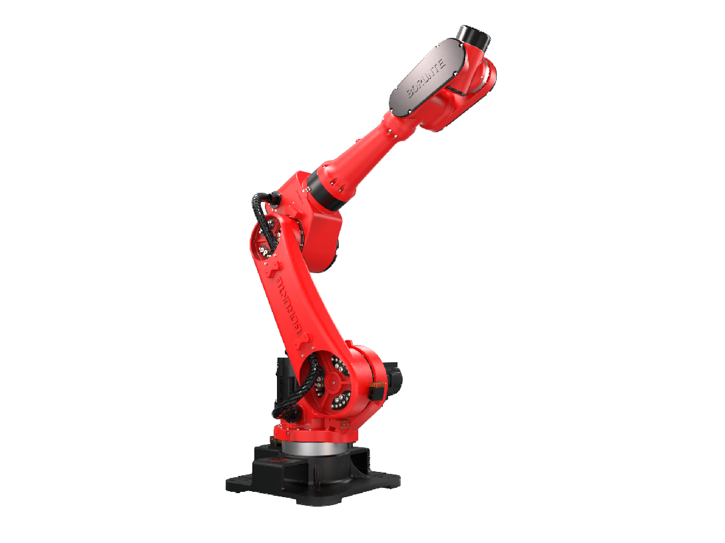

（Without further notice if specification and exterior have been changed because of improvement. Thanks for your understanding.）

- BRTIRUS2550A robot profile
  - Introduction of BRTIRUS2550A

BRTIRUS2550A is a six axis robot developed by BORUNTE for complex applications with multiple degrees of freedom. It has an ultra long arm span of 2563mm and a maximum load of 50kg. With six degrees of flexibility, it can handle scenarios such as loading and unloading, assembly, and injection molding with ease.
High accuracy：repeated positioning accuracy: ±0.1mm

1.2. Application cases of BRTIRUS2550A

(1). injection molding (2). stamping (3). palletizing (4). loading and unloading, etc.

3. BRTIRUS2550A robot specifications
Model |  |  | BRTIRUS2550A
Axes |  |  | 6 axis
Loading ability |  |  | 50kg
Repeated positioning accuracy |  |  | ±0.1mm
Maximum arm span |  |  | 2563mm
Weight |  |  | 725kg
Max speed | J1 |  | 84°/s |  |  |  | J2 |  |  |  |  |  | 52°/s
Max speed | J3 |  | 52°/s |  |  |  | J4 |  |  |  |  |  | 245°/s
Max speed | J5 |  | 223°/s |  |  |  | J6 |  |  |  |  |  | 223°/s
Motion range | J1 |  | ±160° |  |  |  | J2 |  |  |  |  |  | ±70°
Motion range | J3 |  | -75°/+115° |  |  |  | J4 |  |  |  |  |  | ±180°
Motion range | J5 |  | ±125° |  |  |  | J6 |  |  |  |  |  | ±360°
Allowable torque |  |  | J4 | 153N*m |  |  | J5 |  | 153N*m |  |  |  | J6 | 100N*m
Allowable moment of inertia |  |  | J4 | 28kg*m² |  |  | J5 |  | 28kg*m² |  |  |  | J6 | 11kg*m²
Mounting environment | Operating temperature： 0℃~40℃  Best temperature：15℃~25℃  Relative humidity：20~80%RH（No condensation） |  |  |  |  |  |  |  | Mpa |  | 0.5~0.7MPa
Mounting environment |  |  |  |  |  |  |  |  | Power supply |  | 380V±10％ 50Hz/60Hz
Core component | Name | Operating system |  |  |  | Brand |  |  |  |  |  | BORUNTE
Core component | Name | Casting body |  |  |  |  |  |  |  |  |  | BORUNTE
Core component | Name | Servo motor |  |  |  |  |  |  |  |  |  | BORUNTE
Core component | Name | Reducer |  |  |  |  |  |  |  |  |  | BORUNTE
Core component | Name | Electrical component |  |  |  |  |  |  |  |  |  | BORUNTE
Oil content | J1 | 2000ML |  |  | J2 |  |  | 2000ML |  | J3 |  |  |  |  | 700ML
Oil content | J4 | 600ML |  |  | J5 |  |  | 200ML |  | J6 |  |  |  |  | 200ML
Vulnerable parts | J5 timing belt |  | MBT233150515 timing belt 5M-15 Wide:130 teeth black HP
Robot accompanying materials |  |  | USB

The rated power, specifications, external dimensions, etc. of this product are subject to modification without prior notice.
Technical data and illustrations are for supply reference only and reserve the right to make changes.
