Technical Recommendation
Model：BRTMD193501A
Name：35KG palletizing workstation
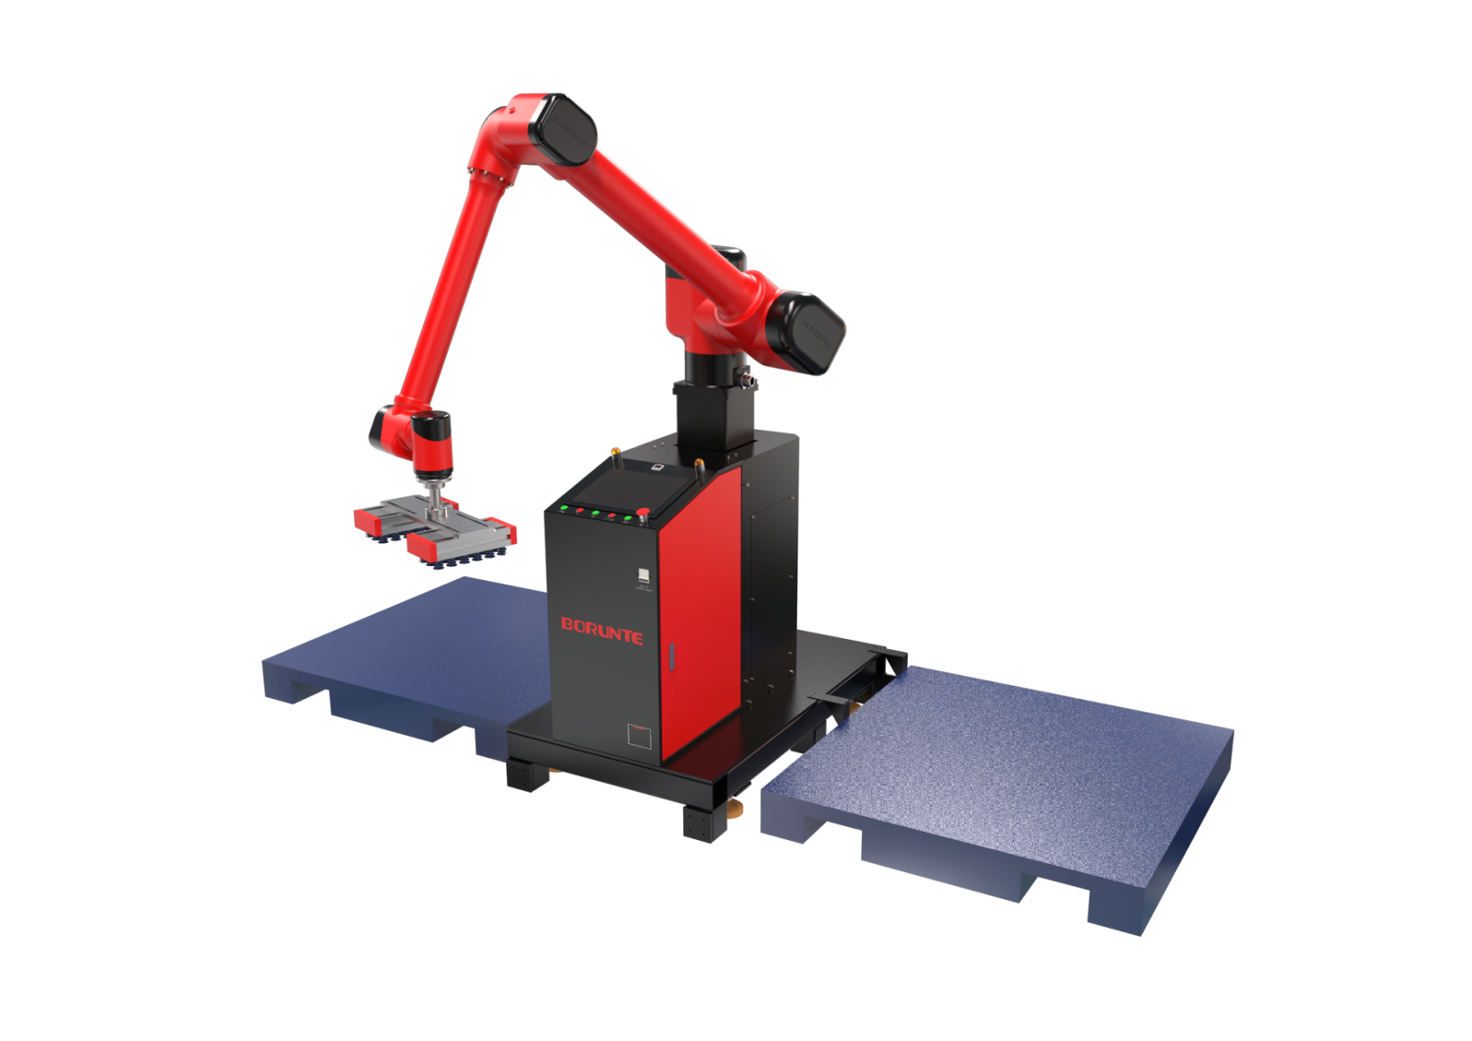
Robot version:10 version

（Without further notice if specification and exterior have been changed because of improvement. Thanks for your understanding.）

1. BRTMD193501A profile

1.1.Introduction of BRTMD193501A
BRTMD193501A is a workstation developed by BORUNTE for the palletizing industry, with a working radius of 1895MM and a load of 35KG. It is composed of a lifting platform and a specialized palletizing large screen system, supporting bilingual operation. It can be widely used in multiple industries such as cardboard boxes, pharmaceuticals, and food, improving the intelligence level of the production line.
1. Flexible deployment: Integrated design, lightweight and flexible, plug and play.
2. Easy programming: graphical display, simple and efficient programming operation, can be easily completed within 10 minutes
3. Standard lifting platform with a lifting height of 0-500MM.
4. The palletizing speed is 9-10 seconds per box, making it easy to complete both left and right palletizing.
5. Reserve connection holes for the conveyor belt, and customers need to configure the conveyor belt according to the hole positions themselves.

1.2. Application cases of BRTMD193501A

(1). palletizing, etc.

2. BRTMD193501A specifications
Model | BRTMD193501A
Axes | 6 axis
Loading ability | 35kg
Repeated positioning accuracy | ±0.1mm
Palletizing height | 2350MM(including pallet height)
Palletizing speed | 9-10 pcs/min
Floor space | 1620*1350MM
Total height of equipment | 3M
Maximum arm span | 1800mm
Weight | About 487kg
Max speed | J1 | 140°/s |  |  | J2 | 140°/s
Max speed | J3 | 122°/s |  |  | J4 | 145°/s
Motion range | J5 | 225°/s |  |  | Elevating Axis | 250mm/s
Motion range | J1 | ±180° |  |  | J2 | ±180°
Motion range | J3 | -60°~+160° |  |  | J4 | ±120°
Allowable torque | J5 | ±360° |  |  | Elevating Axis | 0-500MM
Maximum rotational torque | J4 | 33.6Nm |  |  | J5 | 42Nm
Maximum moment of inertia | J4 | 0.096Kg.m2 |  |  | J5 | 0.096Kg.m2
Mounting environment | Temperature: 0~40 ℃ Humidity: 20-80% RH (no condensation)  Relative humidity：20-80%RH（No condensation） |  |  |  | Mpa | 0.5~0.7MPa
Mounting environment |  |  |  |  | Power supply | 220V±10％  50Hz±1％
Core components | Name | Operating system |  |  | Brand | BORUNTE
Core components | Name | Casting body |  |  | Brand | BORUNTE
Core components | Name | Servo motor |  |  | Brand | BORUNTE
Core components | Name | Reducer |  |  | Brand | BORUNTE
Core components | Name | Electrical component |  |  | Brand | BORUNTE
RV Oil content | J1 | 1700ML | J2 | 860ML | J3 |  | 660ML
RV Oil content | J4 | /
Vulnerable parts | None
Robot accompanying materials | USB

The rated power, specifications, external dimensions, etc. of this product are subject to modification without prior notice.
Technical data and illustrations are for supply reference only and reserve the right to make changes.
