Technical Recommendation
Model：BRTIRUS0805A
Name：Six axis robot
Robot version :21 version
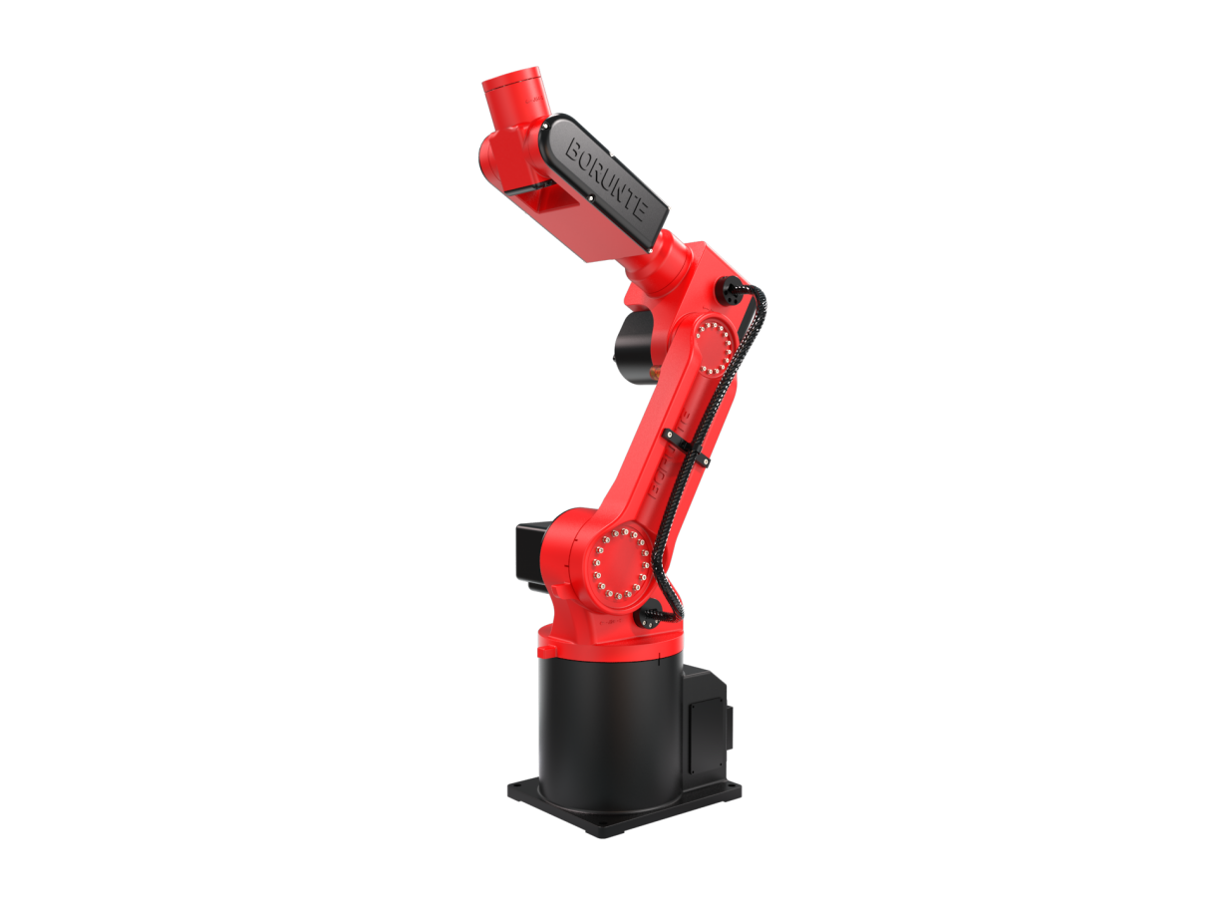

（Without further notice if specification and exterior have been changed because of improvement. Thanks for your understanding.）

1. BRTIRUS080A robot profile

1.1.Introduction of BRTIRUS0805A

BRTIRUS0805A robot is a six axis robot developed by BORUNTE. Robot system is simple to operate, compact in structure, high in positioning accuracy, and has good dynamic performance. Its 5kg load capacity is particularly suitable for injection molding, picking, stamping, handling, loading and unloading, assembling, and other fields, suitable for 30T-250T injection molding machine.
High IP code：IP54
High accuracy：repeated positioning accuracy: ±0.05mm

1.2. Application cases of BRTIRUS0805A

(1). stamping (2). transporting (3). loading and unloading, etc.

2. BRTIRUS0805A robot specifications
Model |  | BRTIRUS0805A
Axes |  | 6 axis
Loading ability |  | 5kg
IP code |  | IP54
Repeated positioning accuracy |  | ±0.05mm
Maximum arm span |  | 990mm
Weight |  | 53kg
Max speed |  | J1 |  | 237°/s |  |  |  | J2 |  | 267°/s
 |  | J3 |  | 370°/s |  |  |  | J4 |  | 337°/s
 |  | J5 |  | 600°/s |  |  |  | J6 |  | 588°/s
Motion range |  | J1 |  | ±170° |  |  |  | J2 |  | -98°/+80°
 |  | J3 |  | -80°/+95° |  |  |  | J4 |  | ±180°
 |  | J5 |  | ±120° |  |  |  | J6 |  | ±360°
Allowable torque |  | J4 | 16N*m |  |  | J5 | 16N*m |  |  | J6 | 5.7N*m
Allowable moment of inertia |  | J4 | 0.17kg*m² |  |  | J5 | 0.17kg*m² |  |  | J6 | 0.048kg*m²
Mounting environment |  | Operating temperature： 0℃~40℃ Best temperature：15℃~25℃ Relative humidity：20~80%RH（No condensation） |  |  |  |  |  |  | Mpa |  |  | 0.5~0.7MPa
 |  |  |  |  |  |  |  |  | Power supply |  |  | 220V±10％ 50Hz/60Hz
Core components |  | Name |  | Operating system |  |  |  | Brand |  | BORUNTE
 |  |  |  | Casting body |  |  |  |  |  | BORUNTE
 |  |  |  | Servo motor |  |  |  |  |  | BORUNTE
 |  |  |  | Reducer |  |  |  |  |  | BORUNTE
 |  |  |  | Electrical component |  |  |  |  |  | BORUNTE
Oil content |  | None
Vulnerable parts | J1timing belt |  |  |  | MBT233090506 Timing belt 5M-09 bandwidth - 68 teeth HP
Vulnerable parts | J4 timing belt |  |  |  | MBT233080306 Timing belt 3M-08 bandwidth - 69 teeth HP
Vulnerable parts | J5 timing belt |  |  |  | MBT233090301 Timing belt 3M-09 bandwidth - 130 teeth
Robot accompany materials |  |  |  |  | USB
The rated power, specifications, external dimensions, etc. of this product are subject to modification without prior notice.
Technical data and illustrations are for supply reference only and reserve the right to make changes.
