Technical Recommendation
Model: BRTYZGT02S2B
Name：Two axis robot
Robot version :21 version
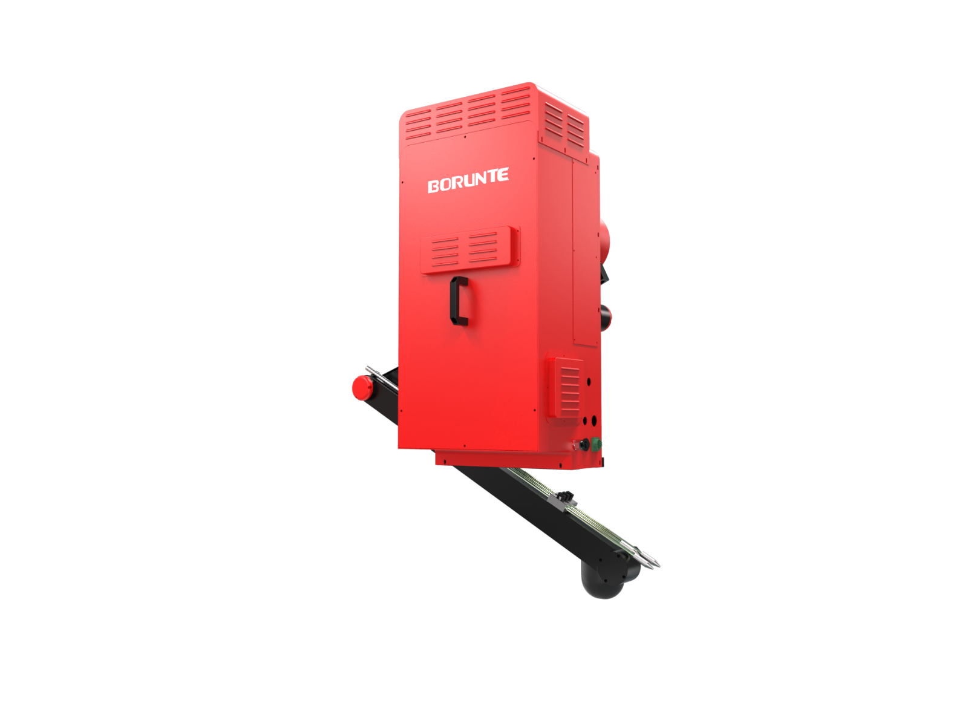（Without further notice if specification and exterior have been changed because of improvement. Thanks for your understanding.）

- BRTYZGT02S2B robot profile
Introduction of BRTYZGT02S2B
  - The BRTYZGT02S2B is a die casting ladling machine developed for automatic molten metal ladling applications. It is suitable for die casting machines from 160T to 400T and has a maximum ladle loading capacity of 4.5 kg. The machine adopts an integrated drive control system with fewer signal lines, making maintenance simpler and operation more stable. It is equipped with a convenient handheld operating device, allowing clear parameter and function settings. The complete structure is driven by a servo motor and RV reducer, providing stable, accurate, and efficient operation during the ladling process. With a cycle time of approximately 6.23 seconds, the BRTYZGT02S2B is suitable for efficient and reliable die casting production environments.

1.2. Application cases of BRTYZGT02S2B

(1). Die casting ladling
(2). Molten metal pouring
(3). Aluminum alloy die casting
(4). Automatic feeding for die casting machines
(5). Foundry production automation

3. BRTYZGT02S2B robot specifications

Items | BRTYZGT02S2B
Applicable to die casting machine | 160T–400T
Manipulator Motor Drive (kW) | 1 kW
Table Spoon Motor Drive (kW) | 0.75 kW
Arm reduction ratio | RV40E 1:153
Ladle reduction ratio | RV20E 1:121
Max. loading (kg) | 4.5 kg
Recommended  table spoon type | 0.8 kg–4.5 kg
Table Spoon Max. (mm) | 350 mm
Recommended height for smelter (mm) | ≤1100 mm
Recommended height for smelter arm | ≤450 mm
Cycle Time | 6.23 s within 4 s, the arm standby position starts to descend until the soup is injected
Main control power | AC Single phase AC220V / 50Hz
Power Source (kVA) | 0.93 kVA
Dimension | Length × width × height: 1140 × 680 × 1490 mm
Weight (kg) | 220 kg

The rated power, specifications, external dimensions, etc. of this product are subject to modification without prior notice.
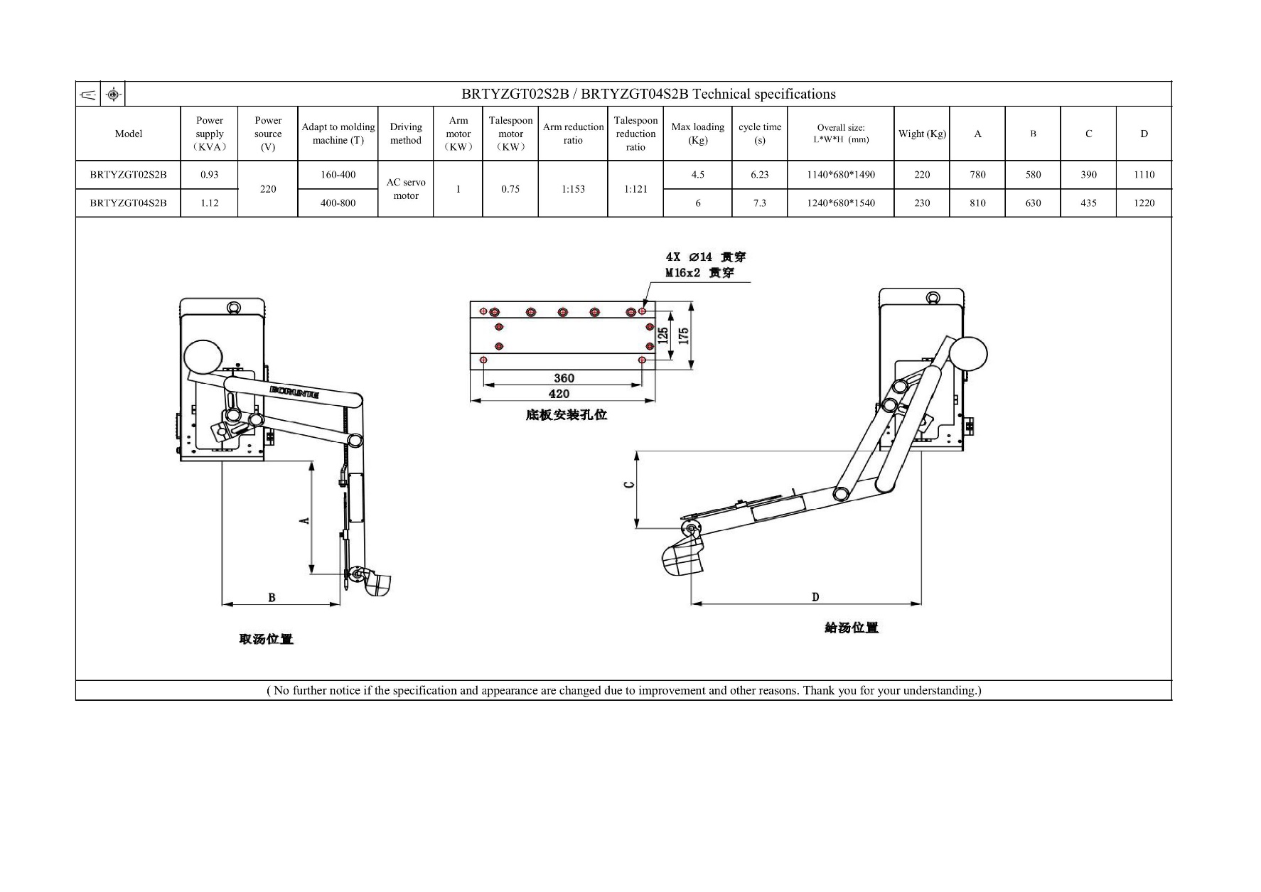
Technical data and illustrations are for supply reference only and reserve the right to make changes.

