Technical Recommendation
Model：BRTIRUS2110A
Name：Six axis robot
Robot version :21 version
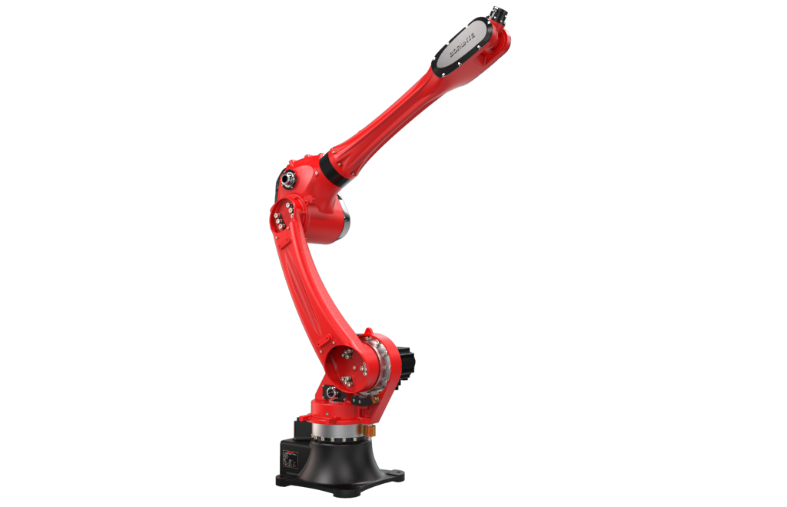

（Without further notice if specification and exterior have been changed because of improvement. Thanks for your understanding.）”

1. BRTIRUS2110A robot profile

1.1.Introduction of BRTIRUS2110A

BRTIRUS2110A is a six axis robot developed by BORUNTE for complex applications with multiple degrees of freedom. It has a 2131mm long arm span and a maximum load of 10kg. With six degrees of flexibility, it can handle scenarios such as welding, loading and unloading, and assembling.
High accuracy：repeated positioning accuracy: ±0.05mm

1.3. Application cases of BRTIRUS2110A
(1). welding (2). injection molding (3). stamping (4). loading and unloading, etc.

2.BRTIRUS2110A robot specifications
Model |  | BRTIRUS2110A
Axes |  | 6 axis
Loading ability |  | 10kg
Repeated positioning accuracy |  | ±0.05mm
Maximum arm span |  | 2131mm
Weight |  | 230kg
Max speed | J1 | 110°/s |  |  | J2 |  |  |  |  | 146°/s
Max speed | J3 | 134°/s |  |  | J4 |  |  |  |  | 273°/s
Max speed | J5 | 300°/s |  |  | J6 |  |  |  |  | 342°/s
Motion range | J1 | ±155° |  |  | J2 |  |  |  |  | -140°/+65°
Motion range | J3 | -75°/+110° |  |  | J4 |  |  |  |  | ±180°
Motion range | J5 | ±115° |  |  | J6 |  |  |  |  | ±360°
Allowable torque | J4 | 52N*m |  | J5 |  | 33.6N*m |  |  |  |  |  | J6 |  |  | 16.8N*m
Allowable moment of inertia | J4 | 0.664kg*m² |  | J5 |  | 1.12kg*m² |  |  |  |  |  | J6 |  |  | 0.155kg*m²
Mounting environment | Operating temperature： 0℃~40℃  Best temperature：15℃~25℃  Relative humidity：20~80%RH（No condensation） |  |  |  |  |  |  | Mpa |  |  |  |  |  | 0.5~0.7MPa
Mounting environment |  |  |  |  |  |  |  | Power supply |  |  |  |  |  | 220V±10％ 50Hz/60Hz
Core component | Name | Operating system |  |  |  |  |  |  | Brand |  |  |  | BORUNTE
Core component | Name | Casting body |  |  |  |  |  |  |  |  |  |  | BORUNTE
Core component | Name | Servo motor |  |  |  |  |  |  |  |  |  |  | BORUNTE
Core component | Name | Reducer |  |  |  |  |  |  |  |  |  |  | BORUNTE
Core component | Name | Electrical component |  |  |  |  |  |  |  |  |  |  | BORUNTE
Oil content | J1 | 1400ML | J2 |  |  |  | 1000ML |  |  |  | J3 |  |  |  |  | 800ML
Oil content | J4 | 250ML | J5 |  |  |  | / |  |  |  | J6 |  |  |  |  | /
Vulnerable parts | Timing belt | Tooth shape 3M, 100 teeth, 6mm wide, reinforced
Vulnerable parts | Timing belt | Tooth shape 3M, 145 teeth, 6mm wide, reinforced
Robot accompanying materials |  | USB

The rated power, specifications, external dimensions, etc. of this product are subject to modification without prior notice.
Technical data and illustrations are for supply reference only and reserve the right to make changes.
