Technical Recommendation
Model: BRTIRPZ3013A
Name：Four axis robot
Robot version: 21 version
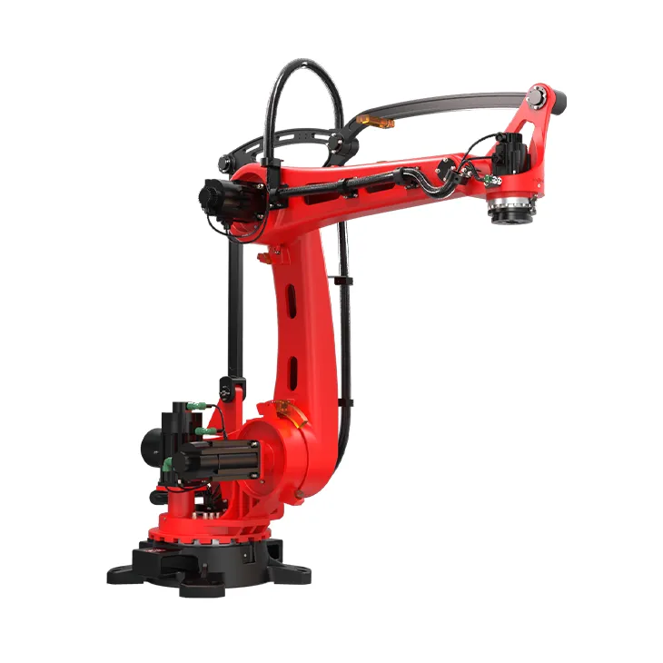
（Without further notice if specification and exterior have been changed because of improvement. Thanks for your understanding.）

1. BRTIRPZ3013A robot profile

1.1.Introduction of BRTIRPZ3013A

BRTIRPZ3013A:
BRTIRPZ3013A is a four-axis stacking/palletizing robot developed by BORUNTE for certain monotonous, frequent, and repetitive long-term operations, or for use in dangerous and harsh environments. It has a maximum arm span of 3020mm and a maximum load of up to 130kg. With multiple degrees of flexibility, it can be used for loading and unloading, handling, dismantling, stacking, and palletizing applications.
Protection grade: IP50 / Dust-proof
High accuracy: repeated positioning accuracy: ±0.15mm
Let op: sommige bronnen noemen IP40 of IP54/IP50 verschillend, maar DirectIndustry vermeldt specifiek IP50 dust-proof voor de BRTIRPZ3013A. BORUNTE zelf vermeldt 3020mm, 130kg en ±0.15mm.

1.2. Application cases of BRTIRPZ3013A

(1). loading and unloading
(2). handling
(3). stacking and palletizing
(4). dismantling, etc.

2. BRTIRPZ3013A robot specifications
Model | BRTIRPZ3013A
Axes | 4 axis
Loading ability | 130kg
IP code | IP40 Dust-proof and water-proof
Repeated positioning accuracy | ±0.15mm
Maximum arm span | 3020mm
Weight | 1200kg
Max speed | J1 |  |  |  | 57°/s |  |  | J2 |  |  |  |  |  | 53°/s
Max speed | J3 |  |  |  | 53°/s |  |  | J4 |  |  |  |  |  | 53°/s
Motion range | J1 |  |  |  | ±160° |  |  | J2 |  |  |  |  |  | -75°/+30°
Motion range | J3 |  |  |  | -55°/+60° |  |  | J4 |  |  |  |  |  | ±180°
Allowable torque | J4 |  | 20.8N*m |  |  |  | J5 | 33.6N*m |  |  | J6 |  |  |  | 16.83N*m
Allowable moment of inertia | J4 |  | 0.17kg*m² |  |  |  | J5 | 0.62kg*m² |  |  | J6 |  |  |  | 0.155kg*m²
Mounting environment | Operating temperature： 0℃~40℃  Best temperature：15℃~25℃  Relative humidity：20~80%RH（No condensation） |  |  |  |  |  |  |  |  | Mpa |  | 0.5~0.7MPa
Mounting environment |  |  |  |  |  |  |  |  |  | Power supply |  | 220V±10％ 50Hz/60Hz
Core components | Name |  |  | Operating system |  |  |  |  | Brand |  |  |  | BORUNTE
Core components |  |  |  | Casting body |  |  |  |  |  |  |  |  | BORUNTE
Core components |  |  |  | Servo motor |  |  |  |  |  |  |  |  | BORUNTE
Core components |  |  |  | Reducer |  |  |  |  |  |  |  |  | BORUNTE
Core components |  |  |  | Electrical component |  |  |  |  |  |  |  |  | BORUNTE
Oil content | J1 |  |  |  |  | 5400ML
 | J2 |  |  |  |  | 1800ML
 | J3 |  |  |  |  | 1800ML
 | J4 |  |  |  |  | 400ML
Robot accompany materials |  | USB
The rated power, specifications, external dimensions, etc. of this product are subject to modification without prior notice. Technical data and illustrations are for supply reference only and reserve the right to make changes.

