Technical Recommendation
Model：BRTIRUS0707A
Name：Six axis robot
Robot version: 21 version
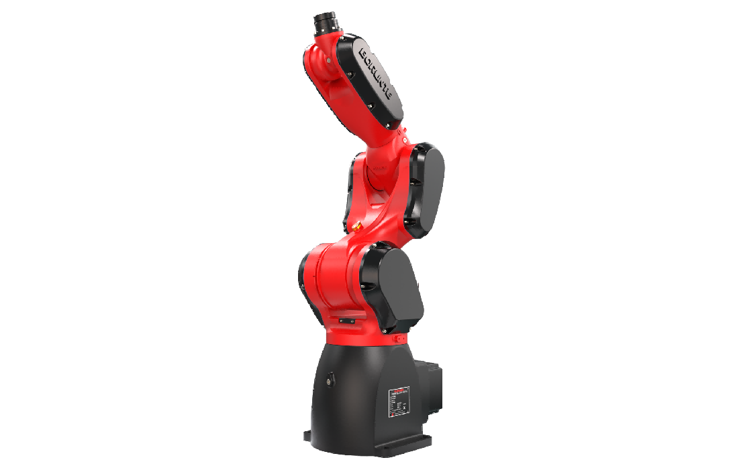

（Without further notice if specification and exterior have been changed because of improvement. Thanks for your understanding.）

1. BRTIRUS0707A robot profile

1.1.Introduction of BRTIRUS0707A

BRTIRUS0707A is a six axis robot developed by BORUNTE for certain monotonous, frequent, and repetitive long-term operations, or in dangerous and harsh environments. It has a 883mm arm span and a maximum load of up to 7kg. With multiple degrees of flexibility, it can be used in polishing, assembling, and spraying.
High IP code：IP65 Dust-proof and water-proof
High accuracy：repeated positioning accuracy: ±0.03mm

1.2. Application cases of BRTIRUS0707A

(1). assembly (2). spraying (3). loading and unloading, etc.

2. BRTIRUS0707A robot specifications
Model |  | BRTIRUS0707A
Axes |  | 6 axis
Loading ability |  | 7kg
IP code |  | IP65 Dust-proof and water-proof
Repeated positioning accuracy |  | ±0.03mm
Maximum arm span |  | 883mm
Weight |  | 55kg
Max speed |  | J1 |  |  |  | 220.8°/s |  |  | J2 |  |  |  |  |  | 270°/s
 |  | J3 |  |  |  | 375°/s |  |  | J4 |  |  |  |  |  | 308°/s
 |  | J5 |  |  |  | 300°/s |  |  | J6 |  |  |  |  |  | 342°/s
Motion range |  | J1 |  |  |  | ±174° |  |  | J2 |  |  |  |  |  | -125°/+85°
 |  | J3 |  |  |  | -60°/+165° |  |  | J4 |  |  |  |  |  | ±180°
 |  | J5 |  |  |  | ±120° |  |  | J6 |  |  |  |  |  | ±360°
Allowable torque |  | J4 |  | 20.8N*m |  |  |  | J5 | 33.6N*m |  |  | J6 |  |  |  | 16.83N*m
Allowable moment of inertia |  | J4 |  | 0.17kg*m² |  |  |  | J5 | 0.62kg*m² |  |  | J6 |  |  |  | 0.155kg*m²
Mounting environment |  | Operating temperature： 0℃~40℃  Best temperature：15℃~25℃  Relative humidity：20~80%RH（No condensation） |  |  |  |  |  |  |  |  | Mpa |  | 0.5~0.7MPa
 |  |  |  |  |  |  |  |  |  |  | Power supply |  | 220V±10％ 50Hz/60Hz
Core components |  | Name |  |  | Operating system |  |  |  |  | Brand |  |  |  | BORUNTE
 |  |  |  |  | Casting body |  |  |  |  |  |  |  |  | BORUNTE
 |  |  |  |  | Servo motor |  |  |  |  |  |  |  |  | BORUNTE
 |  |  |  |  | Reducer |  |  |  |  |  |  |  |  | BORUNTE
 |  |  |  |  | Electrical component |  |  |  |  |  |  |  |  | BORUNTE
Oil content |  | J4 |  |  |  |  | 50ML
Vulnerable parts | J6timing belt | MBT233060306 Timing belt HP-3M-06 Bandwidth - 145 Toothed belt length 435
Vulnerable parts | J5timing belt | MBT233060307 Timing belt HP-3M-06 Bandwidth - 100 Toothed belt length 300
Vulnerable parts | J3timing belt | MBT233090508 Timing belt HP-5M-09 bandwidth - 95 tooth belt length 475
Vulnerable parts | J1timing belt | MBT233090506 Timing belt HTD-5M-HP-68 teeth - 9mm wide
Robot accompany materials |  |  | USB
The rated power, specifications, external dimensions, etc. of this product are subject to modification without prior notice. Technical data and illustrations are for supply reference only and reserve the right to make changes.
