Technical Recommendation
Model：BRTIRPL1608A
Name：Four axis robot
Robot version :21 version
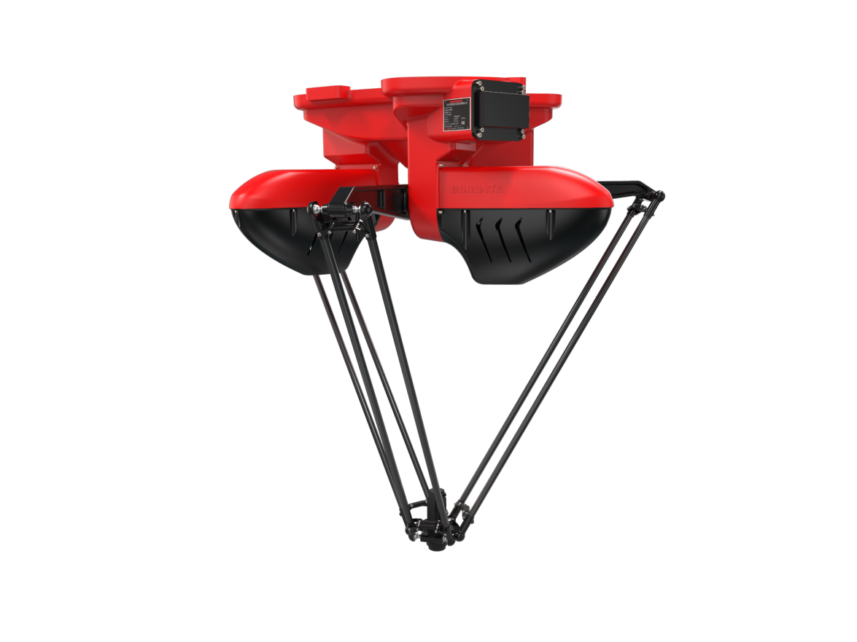

（Without further notice if specification and exterior have been changed because of improvement. Thanks for your understanding.）”

1. BRTIRPL1608A robot profile

1.1.Introduction of BRTIRPL1608A

BRTIRPL1608A is four axis robot developed by BORUNTE for assembling, sorting, and other application scenarios of light and small scattered materials. It can be paired with vision and has a 1600mm arm span, with a maximum load of 8kg.
High accuracy：repeated positioning accuracy:±0.1mm

1.2. Application cases of BRTIRPL1608A

(1). sorting (2). transporting, etc.

2. BRTIRPL1608A robot specifications
Model | BRTIRPL1608A
Axes | 4 axis
Loading ability | 8kg
Repeated positioning accuracy | ±0.1mm
Angle repeated positioning accuracy | ±0.5°
Maximum arm span | 1600mm
Weight | 95kg
Max speed | J1 | 463°/s |  |  | J2 |  | 463°/s
Max speed | J3 | 463°/s |  |  | J4 |  | 600°/s
Motion range | J1 | -38°/+98° |  |  | J2 |  | -38°/+98°
Motion range | J3 | -38°/+98° |  |  | J4 |  | ±360°
Maximum rotational torque | J4 | \
Maximum moment of inertia | J4 | \
Cycle time (times/min)  （25-305-25mm） | 0kg | 3kg |  |  | 5kg |  | 8kg
Cycle time (times/min)  （25-305-25mm） | 150 | 150 |  |  | 130 |  | 115
S Acceleration and deceleration time | 0.05s/0.06s | 0.05s/0.06s |  |  | 0.07s/0.09s |  | 0.08s/0.09s
Maximum linear speed | 2.6m/s | 2.6m/s |  |  | 2.6m/s |  | 2.2m/s
Mounting environment | Operating temperature： 0℃-40℃  Relative humidity：20-80%RH（No condensation） |  | Mpa |  |  | 0.5~0.7MPa
Mounting environment |  |  | Power supply |  |  | 220V±10％ 50Hz/60Hz
Core component | Names | Operating system |  | Brand | BORUNTE
Core component | Names | Casting body |  | Brand | BORUNTE
Core component | Names | Servo motor |  | Brand | BORUNTE
Core component | Names | Reducer |  | Brand | BORUNTE
Core component | Names | Electrical component |  | Brand | BORUNTE
Oil content | J4 |  |  |  | 25ML
Vulnerable parts | None
Robot accompanying materials | USB

The rated power, specifications, external dimensions, etc. of this product are subject to modification without prior notice.
Technical data and illustrations are for supply reference only and reserve the right to make changes.
